**-- запрос 2**

**SELECT amt, odate**

**FROM orders**

**WHERE snum = 1**

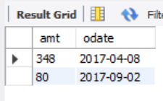

-- запрос 3

SELECT amt, odate

FROM orders

where snum = (SELECT snum

FROM salespeople

WHERE sname = 'Колованов');



-- запрос 4

SELECT snum, sname

FROM salespeople

where snum IN (SELECT snum

FROM orders

WHERE YEAR(odate) = 2016)

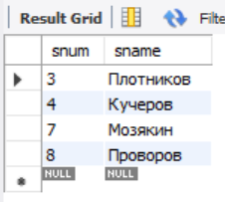

-- запрос 5

SELECT cname as 'Покупатель', sname as 'Продавец'

FROM customers cus, salespeople sal

where (cus.cnum, sal.snum) IN (SELECT cnum, snum

FROM orders

WHERE YEAR(odate) = 2017)

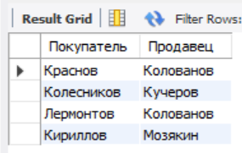

-- запрос 6

SELECT *

FROM orders

where cnum = (SELECT cnum

FROM customers

WHERE cname = 'Краснов');

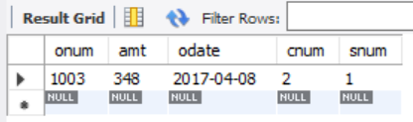

-- запрос 7

SELECT cname, rating

FROM customers

where cnum IN (SELECT cnum

FROM orders

WHERE amt > (SELECT AVG(amt)

from orders))

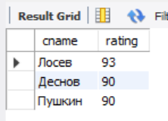

-- запрос 8

SELECT snum, SUM(AMT)

FROM orders

GROUP BY snum

HAVING SUM(amt) > (SELECT MAX(amt)

FROM orders);

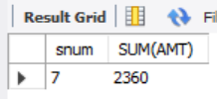

-- запрос 9

SELECT *

FROM orders

where cnum IN (SELECT cnum

FROM customers

WHERE city = 'Москва');

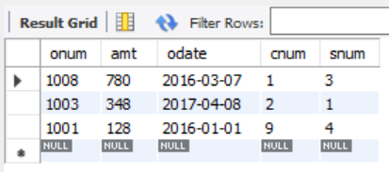

-- запрос 10

SELECT amt, odate

FROM orders

WHERE AMT = (SELECT MAX(AMT)

FROM orders)

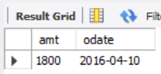

-- запрос 11

SELECT cname

FROM customers

WHERE cnum IN (SELECT cnum

FROM orders

WHERE amt = (SELECT MAX(amt)

FROM orders));

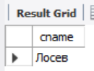

-- агрегатная функция SUM

SELECT SUM(amt)

FROM Orders

WHERE odate BETWEEN '2016-01-01' and '2016-12-31';

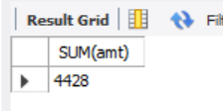

-- агрегатная функция MIN и MAX

SELECT MAX(amt), MIN(amt)

FROM Orders

WHERE amt < 1000;

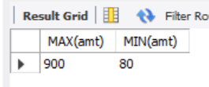

SELECT (MAX(amt) - MIN(amt)) AS 'Разница'

FROM Orders;

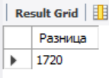

-- агрегатная функция COUNT

SELECT COUNT(*), COUNT(DISTINCT snum)

FROM Orders;

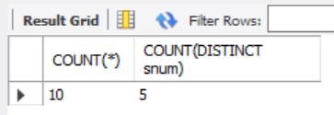

-- агрегатная функция GROUP BY

SELECT snum, SUM(amt) AS 'Сумма всех заказов'

FROM Orders

GROUP BY snum;

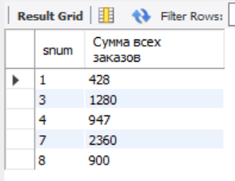

-- агрегатная функция HAVING

SELECT snum, SUM(amt) AS 'Сумма всех заказов'

FROM Orders

GROUP BY snum

HAVING MAX(amt) > 1000;

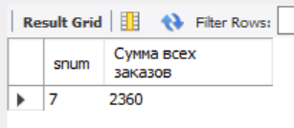

-- доп. запрос 1

SELECT SUM(amt)

FROM Orders

WHERE odate = '2016-01-01';

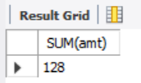

-- доп. запрос 2

SELECT COUNT(DISTINCT city)

FROM customers;

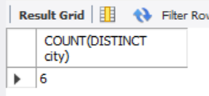

-- доп. запрос 3

SELECT cnum, MIN(amt)

FROM orders

GROUP BY cnum;

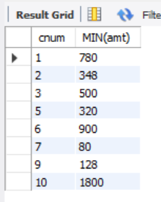

-- доп. запрос 4

SELECT cname

FROM customers

WHERE cname LIKE 'Г%' ;

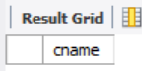

-- доп. запрос 5

SELECT city, MAX(rating)

FROM customers

GROUP BY city;

